**Question 1:** A hexagonal pyramid of base side 20 mm and axis 50 mm long, rests with its base on HP and an edge of its base is perpendicular to VP. It is cut by a section plane perpendicular to VP, inclined at 30˚ to HP and passing through a point on the axis 14.5 mm below the apex. Draw the sectional side view and sectional top view.

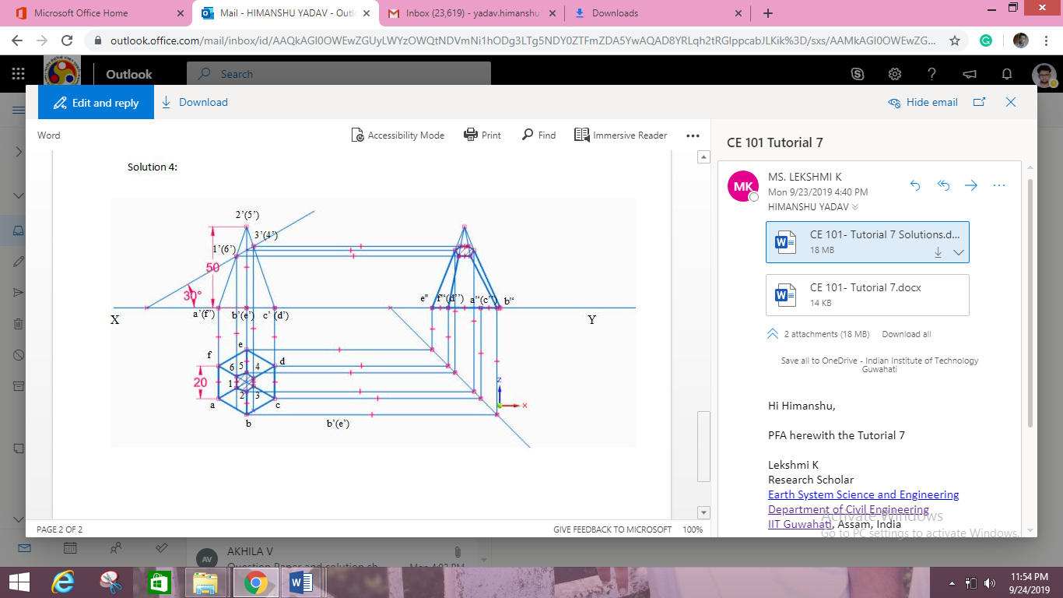

**Question 2:** A Square prism, side of base 35 mm and axis 70 mm long, rests with its base on H.P. and one of its rectangular faces is inclined at 40o to VP. A section Plane perpendicular to V.P. and inclined at 60o to H.P. cuts the axis of the prism at a point 30 mm from its top end. Draw the sectional top view and true shape of the section.

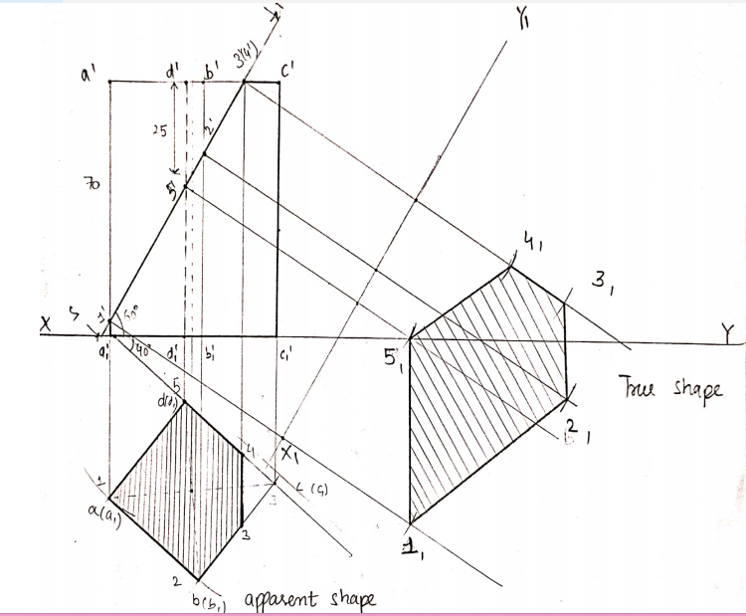

**Question 3:** A cone, base 45 mm diameter and axis 55 mm long is resting on the H.P. on its base. It is cut by a section plane, perpendicular to both the H.P. and the V.P. and 6 mm away from the axis. Draw its front view, top view and sectional side view.

